GET DATA
/TYPE=TXT
/FILE="/Users/srlab/Dropbox/Lab/Dave/Manila OA/Total Reads mapped to Ruphi.csv"
/DELCASE=LINE
/DELIMITERS=" ,"
/QUALIFIER='"'
/ARRANGEMENT=DELIMITED
/FIRSTCASE=2
/IMPORTCASE=ALL
/VARIABLES=
V1 A26
V2 F5.0
V3 F6.0
V4 F7.3
V5 A18
V6 F5.0
V7 F1.0
V8 F1.0.
CACHE.
EXECUTE.
DATASET NAME DataSet1 WINDOW=FRONT.
* Chart Builder.
GGRAPH
/GRAPHDATASET NAME="graphdataset" VARIABLES=V4 MISSING=LISTWISE REPORTMISSING=NO
/GRAPHSPEC SOURCE=INLINE.
BEGIN GPL
SOURCE: s=userSource(id("graphdataset"))
DATA: V4=col(source(s), name("V4"))
GUIDE: axis(dim(1), label("V4"))
GUIDE: axis(dim(2), label("Frequency"))
ELEMENT: interval(position(summary.count(bin.rect(V4))), shape.interior(shape.square))
END GPL.

GGraph

Notes
Output Created |  | 14-Mar-2012 11:42:23
Comments
Input | Data | /Users/srlab/Dropbox/Lab/Dave/Manila OA/Total Reads mapped to Ruphi.csv
Input | Active Dataset | DataSet1
Input | Filter | <none>
Input | Weight | <none>
Input | Split File | <none>
Input | N of Rows in Working Data File | 27414
Syntax |  | GGRAPH  /GRAPHDATASET NAME="graphdataset" VARIABLES=V4 MISSING=LISTWISE REPORTMISSING=NO  /GRAPHSPEC SOURCE=INLINE.  BEGIN GPL  SOURCE: s=userSource(id("graphdataset"))  DATA: V4=col(source(s), name("V4"))  GUIDE: axis(dim(1), label("V4"))  GUIDE: axis(dim(2), label("Frequency"))  ELEMENT: interval(position(summary.count(bin.rect(V4))), shape.interior(shape.square))  END GPL.
Resources | Processor Time | 00 00:00:02.365
Resources | Elapsed Time | 00 00:00:03.000

[DataSet1]

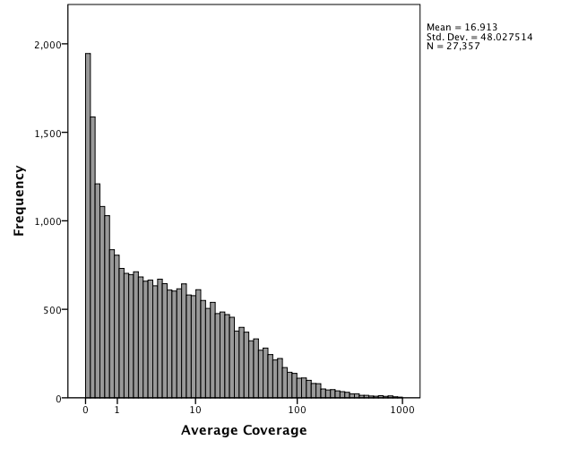

* Chart Builder.
GGRAPH
/GRAPHDATASET NAME="graphdataset" VARIABLES=V3 MISSING=LISTWISE REPORTMISSING=NO
/GRAPHSPEC SOURCE=INLINE.
BEGIN GPL
SOURCE: s=userSource(id("graphdataset"))
DATA: V3=col(source(s), name("V3"))
GUIDE: axis(dim(1), label("V3"))
GUIDE: axis(dim(2), label("Frequency"))
ELEMENT: interval(position(summary.count(bin.rect(V3))), shape.interior(shape.square))
END GPL.

GGraph

Notes
Output Created |  | 14-Mar-2012 11:44:34
Comments
Input | Data | /Users/srlab/Dropbox/Lab/Dave/Manila OA/Total Reads mapped to Ruphi.csv
Input | Active Dataset | DataSet1
Input | Filter | <none>
Input | Weight | <none>
Input | Split File | <none>
Input | N of Rows in Working Data File | 27414
Syntax |  | GGRAPH  /GRAPHDATASET NAME="graphdataset" VARIABLES=V3 MISSING=LISTWISE REPORTMISSING=NO  /GRAPHSPEC SOURCE=INLINE.  BEGIN GPL  SOURCE: s=userSource(id("graphdataset"))  DATA: V3=col(source(s), name("V3"))  GUIDE: axis(dim(1), label("V3"))  GUIDE: axis(dim(2), label("Frequency"))  ELEMENT: interval(position(summary.count(bin.rect(V3))), shape.interior(shape.square))  END GPL.
Resources | Processor Time | 00 00:00:00.883
Resources | Elapsed Time | 00 00:00:01.000

[DataSet1]

